GDPR Privacy Policy

Introduction
In order to provide a quality early years and childcare service and comply with legislation, we will request information from parents about their child and family, some of this will be personal data.

We take families’ privacy seriously, and in accordance with the General Data Protection Regulation (GDPR), we will process any personal data according to the seven principles below:

What does the law say? | What does this mean for you?
Personal data shall be processed lawfully, fairly and in a transparent manner in relation to the data subject. | We must have a lawful reason for collecting personal data, and must do it in a fair and transparent way. We will be clear about what data we are collecting, and why.
Personal data shall be collected for specified, explicit and legitimate purposes and not further processed in a manner that is incompatible with those purposes. | We must only use the data for the reason it is initially obtained. This means that we may not use a person’s data to market a product or service to them that is unconnected to the reasons for which they shared the data with me in the first place.
Personal data shall be adequate, relevant and limited to what is necessary in relation to the purposes for which they are processed. | We must not collect any more data than is necessary. We will only collect the data We need to hold in order to do the job for which we have collected the data.
Personal data shall be accurate and, where necessary, kept up to date. | We will ensure that the data is accurate, and ask parents to check periodically and confirm that the data held is still accurate.
Personal data shall be kept in a form which permits identification of data subjects for no longer than is necessary for the purposes for which the personal data are processed. | We will not keep data any longer than needed. We must only keep the data for as long as is needed to complete the tasks it was collected for.
Personal data shall be processed in a manner that ensures appropriate security of the personal data, including protection against unauthorised or unlawful processing and against accidental loss, destruction or damage, using appropriate technical or organisational measures. | We must protect the personal data. We are responsible for ensuring that we, and anyone else charged with using the data, processes and stores it securely.
The controller shall be responsible for, and be able to demonstrate compliance with the GDPR. | We will be accountable for the data. This means that we will be able to show how we (and anyone working within the company) are complying with the law.

Procedure (how we put the statement into practice)
We are registered with the Information Commissioner’s Office, the UK’s independent authority set up to uphold information rights in the public interest, promoting openness by public bodies and data privacy for individuals.

We expect parents to keep private and confidential any sensitive information they may accidentally learn about staff, the setting or the other children and families attending our setting, unless it is a child protection issue.

From little Caterpillar’s to beautiful Butterflies

Registered No. 04362666
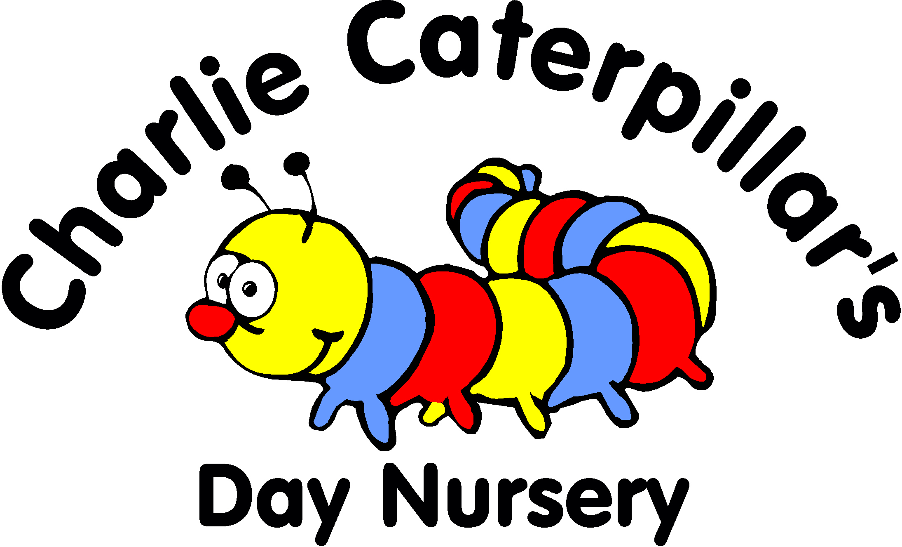

Our passion is childcare

Unit 1, Dorchester Park,
Commercial Road,
Bloxwich,
Walsall,
WS2 7NQ.

Tel: 01922 497136
info@charliecaterpillars.co.uk
www.charliecaterpillars.co.uk

We will be asking parents for personal data about themselves and their child/ren in order to deliver a childcare service (see privacy notice). We are required to hold and use this personal data in order to comply with the statutory framework for the early years foundation stage, Ofsted, Department for Education and our local authority.

Subject access
Parents have the right to inspect records, via parent zone, about their child at any time. This will be provided without delay and no later than one month after the request, which should be made in writing. We will ask parents to regularly check that the data is correct and update it where necessary.

Storage
We will keep all paper-based records about children and their families securely locked away in a locked filing cabinet in a locked office in a secure building.

If we keep records relating to individual children electronically, externally or in cloud storage such as iCloud, Google Drive or Dropbox, including digital photos or videos, we will obtain parents’ permission. This also includes CCTV footage, we will store the information securely, for example, in password-protected files, to prevent viewing of the information by others with access to the files.

Information sharing
We are expected to share information with other childcare providers if a child also attends another setting.

We are also required to share information with Walsall Local Authority in regards to the childcare and early years entitlements.

We will not share any information with anyone without parents’ consent, unless there is a child protection concern.

Ofsted may require access to my records at any time.

Connect Childcare and Parent Zone
From time to time we will need to contact you, via phone, email and the ParentZone app to provide you with nursery updates, share relevant news and send your childcare bills.

We will input your data into a system called Connect Childcare which helps us manage our nursery smoothly. Your data is held in secure data centres and can only be accessed by authorised personnel. Personal information will not be shared with any third parties.

When you join us you will be asked on your admission form to give permission for Charlie Caterpillars to contact you with regard to any information relating to nursery which will give us consent to contact you about nursery matters.

Photographs
For Safeguarding reasons we obtain permission from parents to photograph children during their sessions, under no circumstances should parents take photographs of any children, including own child whilst on the premises of the nursery. Use of Mobile phones is not permitted on the nursery premises. Permission for the nursery to post photographs on social media is sought from all parents, parents are asked to refrain from posting information about the nursery on social media.

Record keeping
We record all accidents on iconnect which are shared via the parent zone app, parent signature is required electronically upon collection.

We will notify Ofsted of any accidents which may result in an insurance claim, e.g. an accident resulting in a doctor or hospital visit. Ofsted will log and acknowledge receipt of the correspondence, information will be shared with Morton Michel who provides our public liability insurance policy to enable a claim number to be allocated.

We will inform Ofsted, the local child protection agency, RIDDOR the Health and Safety Executive of any significant injuries, accidents or deaths as soon as possible.

We record all significant incidents on iconnect which are shared via the parent zone app and will work closely with the parents so that together we can work to resolve any issues.

We will only share information if it is in a child’s best interests to do so. For example in a medical emergency we will share medical information with a healthcare professional. If we are worried about a child’s welfare we have a duty of care to follow the Local Safeguarding Children Board procedures and make a referral. Where possible we will discuss concerns with you before making a referral.

Safe disposal of data
We are required by law to keep some data for some time after a child has left the setting. We have a review plan in place and ensure that any data is disposed of appropriately and securely.

Suspected breach
If we suspect that data has been accessed unlawfully, we will inform the relevant parties immediately and report to the Information Commissioner’s Office within 72 hours. We will keep a record of any data breach.

This policy supports the following safeguarding and welfare requirements: England
Meeting the Early Years Foundation Stage Safeguarding and Welfare Requirements. Information and records

Privacy Policy – May 2018

