
Design and Access Statement February 2025
- Introduction
This design and Access Statement is prepared is support of application number 2023/BR/0574, internal alterations to first floor.

- Existing Site and Building
The existing site, Charlie Caterpillars Day Nursery is located on an industrial estate in Bloxwich, Walsall in between adjoining businesses of Charis Ministries Leamore Lane and Ace Pub Supplies Commercial Road.

The nursery address is as follows;
Charlie Caterpillars Day Nursery Ltd
Unit 1 Dorchester Park,
Commercial Road,
Bloxwich,
Walsall,
WS2 7NQ.

Charlie Caterpillars Day Nursery is part of a converted site of warehouses, office/retail buildings that have been split into multiple occupancies and sold off as individual premises. Charlie Caterpillars occupies a 3 storey building with an enclosed staircase and external fire escape. It is constructed from brick, steel and concrete with a flat concrete room, the external walls are lined with corrugated metal cladding. The internal construction varies from brick walls to a more traditional stud wall method, 1st and 2nd floor have suspended ceilings. It is a late 1960’s construction and is in good condition.

A play area has been built at the front of the building secured by magna lock metal fencing and gates. There is a further play area built at the top of the boundary away from the building which is also a secure Fire Assembly point.

The existing site has its car park situated at the front of the building, with 6 spaces to the right of the main gates and 10 spaces to the left of the main gate.

There is a secure perimeter fence with a secure pedestrian gate leading to a ramped walkway to the main entrance of the building. The main entrance is a double gated driveway, the gates are locked securing the site from 6:30pm to 6:00am.

The driveway is a shared access to the adjoining building, Ace Pub Supplies, they season scratchings and supply snacks to pubs across the country.

- How access issues have been addressed
The nursery is accessed from Fryers Road which leads to the main gates to the car park off Commercial Road.

The nursery is located on a one-way street, it is an established industrial estate and can be found on satnav searches, due to the nature of the business we have signage on the main gate and main entrance to the building, but minimal signage around the site itself. We have generic directional signage to support visitors to the main entrances of the building.

Visitors to the building are always pre-booked and supervised on site, on arrival they will ring the video entry intercom situated on the green door to the main entrance of the building leading to the enclosed internal staircase to the first and second floor (secure area). Visitors will sign into the building on arrival and a further secure door (key coded entry) controlled by a further audio entry intercom, all pre-booked visitors are supervised into the building from this point.

Parent drop off – Ground floor
Ground floor play rooms – parents will drop off their children at the green gates before 8:30am, they will enter the garden and bring children to the nursery door where they are greeted by a staff member. From 8:30am parents will bring their children to the nursery reception door, ring the audio intercom as the garden will be in use from 8:30am, parent’s do not come into the building.

Parent collections – Ground floor
Ground floor play rooms – parents will collect their children from the nursery reception door, ring the audio intercom for attention for their child to be returned to their care, parents do not come into the building.

Parent drop off – First floor
First floor play rooms - parents will ring the video entry intercom situated on the green door to the main entrance of the building leading to the enclosed internal staircase to the first and second floor (secure area). The video intercom will be supervised and managed by a qualified staff member that has a register of all children booked in for the session. Parents will wait at the second secure entrance leading to the enclosed staircase to the first floor, this is (key coded entry) controlled by a further audio entry intercom, parents will bring their child to the main entrance of the play rooms on the first floor, parents do not enter the room.

Parent collections – First floor
First floor floor play rooms - will collect their children from the main entrance to the building, children are bought down into the ground floor corridor at the end of the session to be returned safely in to the care of their parents, parents do not come into the building. In exception if a child is leaving early or has a pre-arranged agreement parents will follow the same procedure as when parents drop off.

Disabled WC provision is located in the ground floor nursery bathrooms. An additional staff/visitors WC provision is located in the ground floor main entrance. There are two further WC provisions along with mini-kitchen facilities located on the second floor for staff/visitors. Visitors are supervised on site and members of the public do not enter the building unless pre-arranged and authorised. Due to the age and physical layout of the building and the nature of the business we work to overcome obstacles to ensure we are meeting the individual needs of children, staff and visitors making reasonable adjustments to ensure that no-one is disadvantaged.

Emergency Exits
Ground floor – All rooms have direct access to the play area, which forms part of the evacuation procedure, in the event of an emergency evacuation children will be escorted safely through the play area, out of the garden gates and upto the assembly point (pre-school garden) located at the far end of the car park away from the bulidng.

First floor – Emergency exits are located at either end of the first floor, the main door to the play rooms is an emergency exit leading to the enclosed internal stair case. A second emergency exit is located at the furthest point of the playrooms leading to an external staircase. The external staircase is not used for public access at anytime.

Second floor – Emergency exits are located at either end of the second floor, the main door to the second floor leading to offices, training room, staff room and resource room is an emergency exit leading to the enclosed internal stair case. A second emergency exit is located at the furthest point of the second floor leading to an external staircase. The external staircase is not used for public access at anytime.

Evacuation plan
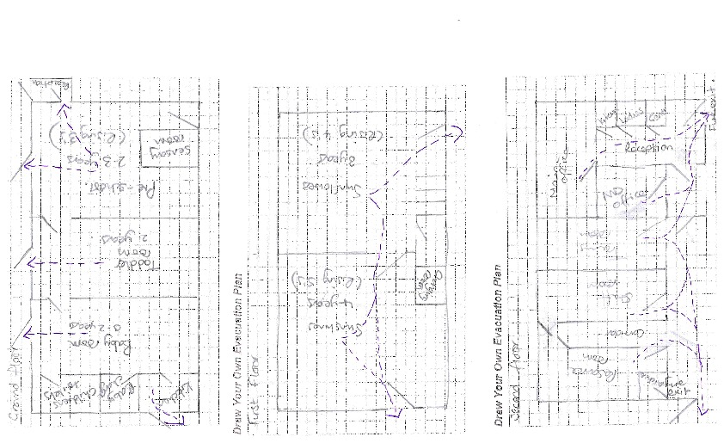

- Please find attached relevant policies and procedures;
  - Visitors policy
  - Health & Safety policy
  - Fire evacuation policy
  - PEEP policy
  - Lockdown policy
  - Inclusion policy
  - Safeguarding policy
  - Safeguarding control measures

- Our aims for accessibility, to be fully inclusive adapting our environment where physically possibly, practice and attitudes to meet the needs of all children, staff and visitors. Due to the physical nature of the building we are unable to overcome the stairs as we are unable to install a lift as there is no space, however if needed we would consider installing a stair lift to improve access to meet

- The following policies are in place to ensure that disabled people of all ages will be able to access all aspects of our provision.

- The standards and guidance we use are:
  - Early Years Foundation Stage
  - British Safety Standards

- Key design elements we have considered are;
  - How people will get around the building
  - Approaches and entrances for shared use
  - Accessible parking and drop-off near entrances and key destination points
  - Levels and how gradients will be accommodated
  - Route widths, surfaces, distance
  - Access to services
  - Lighting (consider people with hearing loss)
  - Access to toilets, cafes and other services
  - Heights of counters, controls (eg sockets, window latches)
  - Seating and shelter
  - Accessible signage, information, communication, intercoms

- Site constraints
  - Environmental factors constrain best practice, identify the nature of constraints, demonstrate why the relevant design standards can’t be achieved and identify proposed alternative solutions

- Management plans
  - How polices and approaches to making your development inclusive will be maintained in the long term, for example maintenance and management plans.

