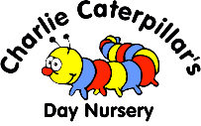
Caring for Sick Children, Medication and Emergency Care Procedure Dec 25
Children cannot remain in Nursery if they are unwell as the nursery is not a suitable environment for a poorly child and the illness presented, if infectious, may present a risk to other children and staff. Parents/carers will be informed immediately and asked to collect their child if a member of staff has any concerns about the well being of the child, Nursery Manager will be informed prior to contacting the parent. The most common reasons are:
- They develop a high temperature.
- They have diarrhoea (x3 episodes if no other symptoms) and/or vomiting.
- They have a fall/bump in which they have received an injury.

Procedure for sending home:
If a child becomes ill whilst at nursery, staff will inform the Nursery Manager immediately. The child’s key person will contact the parent/carer of the child. Staff will give the child comfort and/or necessary first aid whilst waiting for the parents/carers to arrive. Children will be placed on an observation of illness whereby keyperson will record temp, any medical changes every 10mins until parents collect. In the case of a medical emergency we will follow our emergency care procedure below.

Emergency Care:
If a child becomes so unwell or hurt themselves in nursery and it is deemed an emergency the staff team will deal with the situation to the best of their ability. They will:

- Ensure that the child receives the full attention of staff throughout.
- Notify the nursery manager or the Senior acting as deputy on that day
- In an emergency we will call an ambulance immediately without seeking further consent.
- The nursery manager and team will do their upmost to keep the child comfortable until either the parents/carers arrive and/or the child goes to a medical centre.
- The nursery manager will keep in contact with the parents/carers throughout.
- If the child leaves the nursery to seek medical help then a member of staff will accompany them, they will wait with the child until the parents/carers arrive.
- The nursery manager will ensure that written records are kept and that the parents/carers receive a copy of a written report in the (yellow) form of a signed accident form.
- The incident will be thoroughly investigated.
- When the child returns to nursery they will receive support from the team with any on-going issue and fill in the return to nursery/ risk assessment forms.

Injuries/illness that require hospital treatment:
Any injury/illness that occur at home or within the nursery that requires hospital treatment will be recorded onto an (Yellow) Accident/Incident reporting log. Some injuries/illness require the setting to report to other agencies, this form will distinguish if any other steps need to be taken and if the setting needs to adapt any routines or care for the child to attend nursery.

In order to deal with major and minor incidents effectively Charlie Caterpillars will ensure that:
- They adhere to Charlie Caterpillars Day Nursery policies and procedures at all times, including carrying out an regular audits.
- All core staff are first aid trained and fully stocked first aid kits are available on each floor of the nursery, main office, garden and on outings.
- Staff record all accidents and incidents on the relevant forms with accuracy and attention to detail.
- Parents/carers are aware of the existing injury form and how this is reported onto the parentzone app.

The Nursery will regularly review all H&S paperwork to look for patterns and act accordingly recording any findings on the moving forward plan, trigger relevant policy reviews and procedure training.

Infectious Diseases:
At Charlie Caterpillars Day Nursery we follow the guidelines produced by the UK Health Security Agency outlined in the Managing specific infectious diseases A to Z.

These guidelines provide recommendations for exclusion times for specific conditions.

The Nursery will notify parents/carers sharing the NHS guidance if there is an outbreak of an infectious disease.

Similarly, parents must inform staff if their child has been or is unwell in anyway.

Exclusion:
Children will not be accepted back in to Nursery until they are clear of the exclusion period. Parents will be asked to be collect after 3 bouts of diarrhoea, however this will be managements discretion if the child is unwell they may be asked to collect sooner, if the child is known to have stomach issues this will be taken into consideration.

Notifiable Illnesses/diseases:
Any outbreaks will be reported to the UK Health Security Agency using this link Notifiable diseases and how to report them - GOV.UK for help and advice on what and how to report.

Asthma:
At Charlie Caterpillars Day Nursery we welcome children with asthma and recognise that asthma is a condition affecting many children. We will ensure that our nursery supports children with asthma by:
- Encouraging and helping children with asthma to participate fully in activities.
- Ensuring that all of our staff are appropriately trained and informed regarding each child’s individual needs relating to their asthma.
- Helping parents/carers to complete an individual health care plan detailing symptoms and emergency response procedures for their child.
- Ensuring that the other children in our nursery understand asthma, so enabling them to support their friends with asthma and to help their friends avoid the stigma sometimes attached to this chronic condition.
- Reassuring parents/carers of children with asthma that their children are in a safe, caring environment.
- Ensuring that children have immediate access to their reliever inhalers.
- Accessing training and support, including training to support individual children. This includes receiving training from the child’s parent/carer themselves.
- Always adhering to the medication procedure.
- Regularly checking the child’s health care plan with their parent/carer so that it is kept up to date.
- Ensure if going offsite/ forest garden on an outing medication is taken with the child

Medication: See Administering Medication Policy

Parental Responsibility & Medication:
The administration of medicine is primarily a parental responsibility but staff may be asked by parents/carers to perform this task. If the manager agrees then the parents/carers must provide the required medicine and the following information should be visible on the medicine:

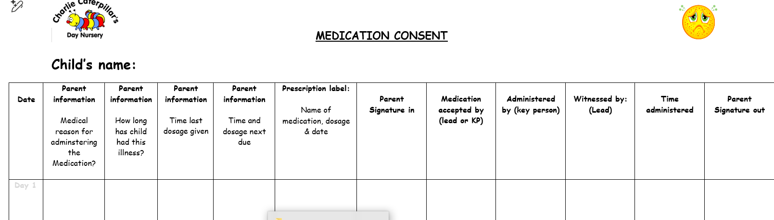

Any changes whatsoever, no matter how minor, to a child’s medication will require a new medication form to be completed and follow-up process to remove the risk of accidental incorrect dosage. It is the parent’s/carer’s responsibility to ensure that the nursery is made aware of any changes to a child’s medication. These changes can be very small, such as a small change in dosage, but to ensure that the correct medication is given at all times, we need a new medication form completed at the time of any change.

During MBWA the Nursery Manager will ensure that the medicine is stored correctly and securely, and use the nursery’s message systems to ensure that all staff know which children require medication and at which times ie. White board, reminder set on ipad or alexa….

When the medicine is given, a qualified staff member will administer and sign the medication form and an accompanying senior staff member will witness and sign the medication form (To be reviewed as this is now causing problems and confusion).

The parent/carer will sign when they collect their child to show they understand we have given the child agreed medication.

It remains the responsibility of the parents/carers to check that nursery have an in date set of medication for their child for children on long term medication such as preventative inhalers or emergency medication such as epi pens.

Teething powders and gels can be administered for the duration of teething but must be signed in and administered under parental consent and guidance, however only for 24 hours.

Childhood Illness Observation record:
If a child has any health problems during nursery time we will record this onto a observation of illness form. This may include:

High temperature
Nose bleeds
Asthma
Skin disorders
Rashes
Anything else deemed as not an accident or injury

Sick Children:
Parents will be required to keep their child at home if unwell. If parents feel that their child is well enough and does not have a contagious illness, then we will care for their needs.
If a child falls ill during the day the parents will be informed and asked to collect.

Injuries at Home:
If a child has received an injury at home, Key persons are required to complete an existing injury form on arrival at nursery this is inputted into iconnect. Similarly, any marks that appear on a child during the nursery day that have not been caused by an accident or incident will be recorded on an existing injury form so that the staff can discuss with the parents in case it was an old injury where a mark has just appeared.

