
Administering Medication Policy Oct 2025
Medication is to be stored in their original containers with prescription labels in the medicine cupboard or fridge located in the room cupboard and for preschool in the preschool kitchen. Staff accepting medication on site must check that they have a pharmacy label displaying the child’s name, dosage and are to ensure the expiry date has not elapsed and a HCP is in place for that child.

Over the counter medication or creams that has not been prescribed by a doctor should not be administered or accepted into nursery.

Non-prescription medication:
Pain and fever relief will not be administered in setting unless prescribed by a doctor for the illness or episode of teething. Teething gel may be administered when there is a health reason to do so. Under these circumstances prior written consent from the parent and authorisation from Management is essential. We will only administer teething remedies if the child is displaying symptoms of discomfort for a maximum of 24 hours. We will administer in accordance with the instructions enclosed in the box of the medication, single sachets will not be accepted.

The medication consent form will be completed with the parent. Both the parent and member of staff accepting the medication must sign the form in black/blue ink pen stating the following, (Long term medication will be pre-printed to support parents). This is a legal document.

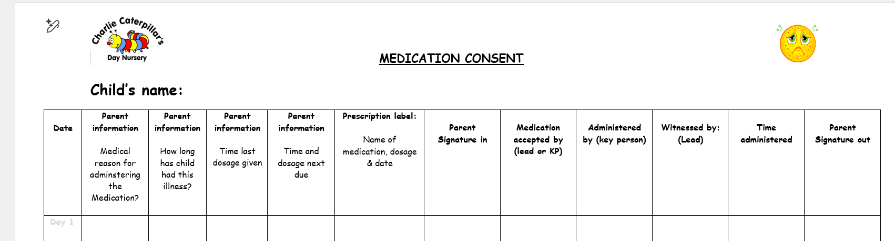

This will be written on the room whiteboard for all staff to see, a reminder alarm for any medication will be set using Alexa or the iPad.

Medication must be given at the time stated by the parent unless there is a valid reason for delay ie; child sleeping.

Medication will be given to the child by a first aid trained key person or key person support (staff member who is most familiar with the child) and witnessed by the first aid trained Senior Lead.

If the administration of prescription medicines requires technical/medical knowledge, then individual training is to be provided from a qualified health professional. Training specific to the individual child concerned before the child is in setting.

No blanket consent is allowed, and medication must be sent home every day and never stored on site.

Details are required of any medication administered to the child prior to attendance that day is recorded on the medication form.

If the child needs emergency medication such as inhalers, epi pens these need to be accessible and always kept in the room or in the garden with the child, children who do not bring their medication will not be permitted onsite, parents will be asked to take the child and return with their medication.

All children with an allergy, intolerance, dietary preference and medical condition must have a detailed health care plan accessible to all room staff, details will also be kept up to date on iconnect ensuring that it includes specific guidance from any medical professionals involved with the child in what actions to take/what constitutes as an emergency for the child.

Following medical advice, we have been advised that we have robust care plans for children with inhalers. We must identify what they are prescribed the inhaler for, for example, asthma, scarring of the lungs, other breathing difficulties etc. We need to include specific advice from the doctor and detail signs we are looking for if the child becomes unwell. The staff team aren’t medically trained to assess signs and symptoms as these can vary per child, so we would need an individual care plan for each child with an inhaler that identifies specific signs of what we are looking for and we need to assess when accepting the child and signing in the medication if the child is well enough to be in setting.

All health care plans should be reviewed termly; these should run alongside parent consultations about development.

Children arriving unwell will be assessed by a member of the management team and advised accordingly. Children with physical symptoms ie. Sticky eyes, sores or rashes etc… parents will be advised to seek medical advice before entry into setting from either a pharmacy or GP and will be accepted depending on the advice. Children that are not deemed well enough to attend will be excluded for periods advised by the UK Health Security Agency.

Managing specific infectious diseases: A to Z - GOV.UK – Exclusion table for schools and other childcare settings. (This document is printed in the policies folder and available on each floor).

We do not dispose of any medication; any medication left on site by children no longer attending will be sent back to a pharmacy for safe disposal.

